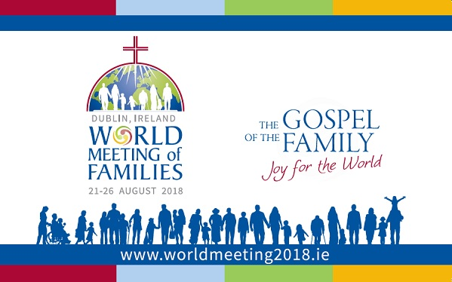

Pope’s Letter for Dublin World Meeting of Families

To the Venerable Brother Cardinal KEVIN FARRELL, Prefect of the Dicastery for the Laity, the Family and Life

At the end of the Eighth World Meeting of Families, held in Philadelphia in September 2015, I announced that the subsequent meeting with Catholic families of the world would take place in Dublin. I now wish to initiate preparations, and am pleased to confirm that it will be held from 21 to 26 August 2018, on the theme “The Gospel of the Family: joy for the world”. Indeed, it is my wish for families to have a way of deepening their reflection and their sharing of the content of the post-Synodal Apostolic Exhortation Amoris Laetitia.

One might ask: does the Gospel continue to be a joy for the world? And also: does the family continue to be good news for today’s world?
I am sure the answer is yes! And this “yes” is firmly based on God’s plan. The love of God is His “yes” to all creation and at the heart of this latter is man. It is God’s “yes” to the union between man and woman, in openness and service to life in all its phases; it is God’s “yes” and His commitment to a humanity that is often wounded, mistreated and dominated by a lack of love. The family, therefore, is the “yes” of God as Love. Only starting from love can the family manifest, spread and regenerate God’s love in the world. Without love, we cannot live as children of God, as couples, parents and brothers.

I wish to underline how important it is for families to ask themselves often if they live based on love, for love and in love. In practice, this means giving oneself, forgiving, not losing patience, anticipating the other, respecting. How much better family life would be if every day we lived according to the words, “please”, “thank you” and “I’m sorry”. Every day we have the experience of fragility and weakness, and therefore we all, families and pastors, are in need of renewed humility that forms the desire to form ourselves, to educate and be educated, to help and be helped, to accompany, discern and integrate all men of good will. I dream of an outbound Church, not a self-referential one, a Church that does not pass by far from man’s wounds, a merciful Church that proclaims the heart of the revelation of God as Love, which is Mercy. It is this very mercy that makes us new in love; and we know how much Christian families are a place of mercy and witnesses of mercy, and even more so after the extraordinary Jubilee. The Dublin meeting will be able to offer concrete signs of this.

I therefore invite all the Church to keep these indications in mind in the pastoral preparation for the next World Meeting.
You, dear Brother, along with your collaborators, have the task of translating in a special way the teaching of Amoris Laetitia, with which the Church wishes families always to be in step, in that inner pilgrimage that is the manifestation of authentic life.

My thoughts go in a special way to the archdiocese of Dublin and to all the dear Irish nation for the generous welcome and commitment involved in hosting such an important event. May the Lord recompense you as of now, granting you abundant heavenly favours.

May the Holy Family of Nazareth guide, accompany and bless your service, and all the families involved in the preparation of the great World Meeting in Dublin.

From the Vatican, 25 March 2017

FRANCIS

